**Cyclic Sort**

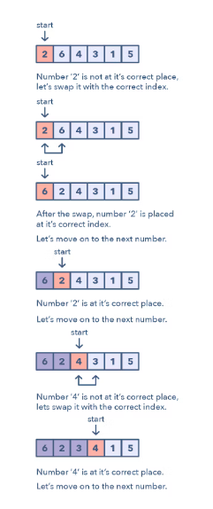

**Ways to Identify the pattern:**

* They will be problems involving a sorted array with numbers in given range
* If the problem asks you to find the missing/duplicate/smallest number in sorted/rotated array

**Common problems you use the sliding window pattern with:**

* Find the Missing Number (easy)
* Find the Smallest Missing Positive Number (medium)

**Broad Categories:**

* None. Lookout for lists saying it has numbers in range n

**Strategies to Solve the Problem:**

* Be very clear on how to swap index and number on index
* Be clear on when to move to next index